Jason Schriner

Module 5/6 Assignment

6/18/25

Connecting MySQL driver to Eclipse

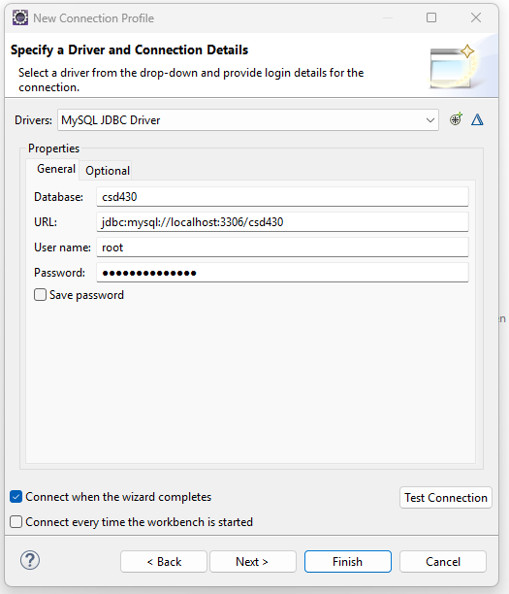

Connection successful

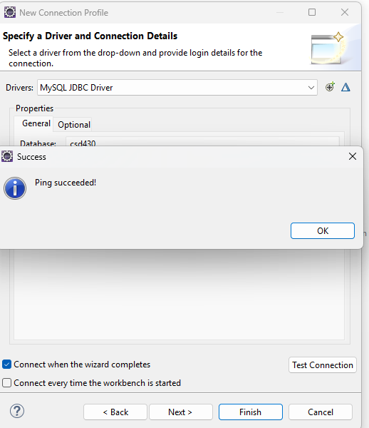

Database appears in list on Eclipse

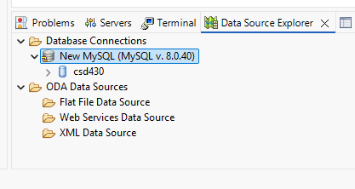

Creation of Tables in MySQL

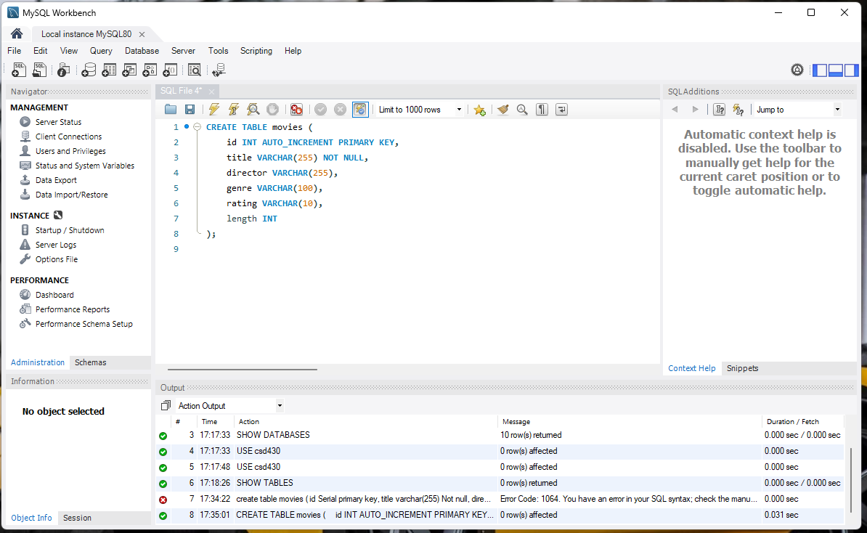

Inserting 10 records into Database.

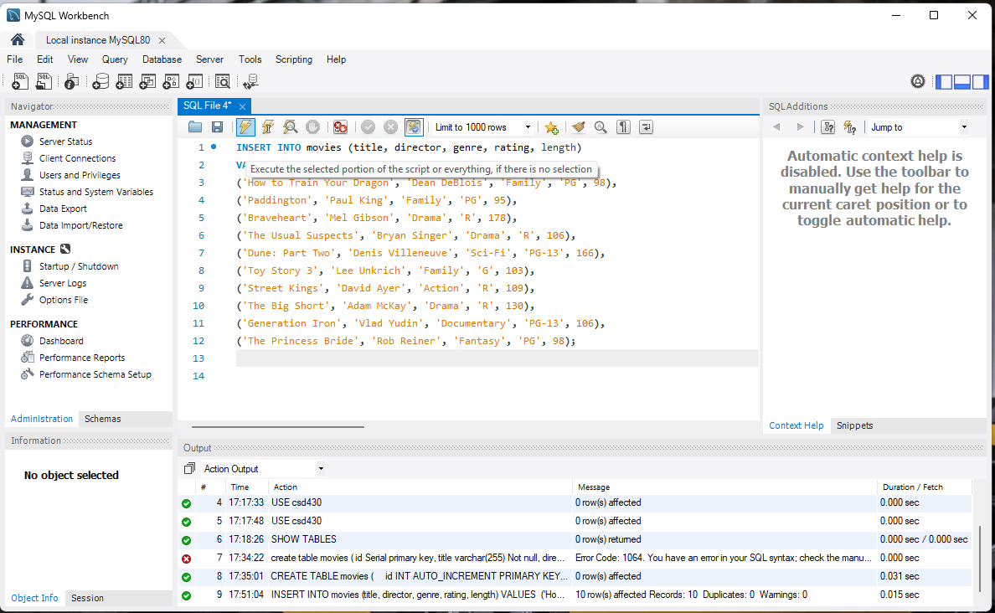

All fields display correctly

